Whitson Chapter No. 2943 Visit
By Comp Norrie Millen
12 Good men and true.....
At the crack of 0800 (or eight bells if you have a nautical background) 12 Companions set off by mini bus kindly driven by E.Comp. Reg Lake of Vale of Haldon Chapter, to attend the Whitson Chapter No. 2943 and to witness an Exultation and Ceremony of the Veils. In attendance were E. Comp’s Don Harrison, Tim Golder, Barry Page, Keith Dixon, Rick Purnell, Brian Tucker, Peter Galli, Chris Sidwell, Reg Lake, David Richards, Terry McGrath, and accompanied by Comp Norrie Millen.
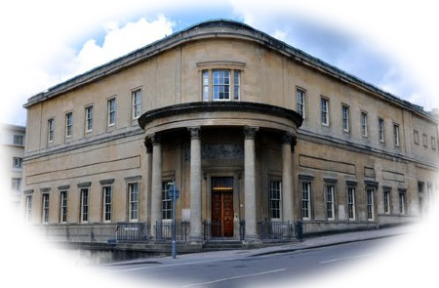
At the ‘eleventh hour’, the Whitson Chapter candidate was taken ill and so E.Comp. Don Harrison was asked if one of Benevolent Chapter No. 303 would like to be the candidate for a demonstration of the ceremony. E.Comp Barry Page got the short (or was it long) straw and volunteered for what was to be a unique and interesting ceremony.
We could not have wished for better weather, dry and sunny all the way to Bristol and the Bristol Temple and luck was on our side as Reg managed to find a parking space quite close to lodge.
We were met by E.Comp. John Standerline, the Treasurer of Whitson Chapter, who first took us to the Provincial Officers’ changing room to leave our regalia, then down to the bar in the basement, where an excellent cup of coffee was served along with biscuits. On completion of refreshment, we were taken on a guided tour of the building which has three Craft temples and two Chapter temples, all of which were absolutely outstanding. Our guide noted here that under Bristol Rite, all below an installed master do not leave the temple at the installation. The installing master, master elect and other principle officers retire to a ‘mini’ lodge room off to the side of main temple for the installation of the new master.
There are 14 Chapters who meet in the building along with 36 craft lodges, all of whom use Bristol Workings as opposed to Emulation ritual. The Centre sees visitors from all over the United Kingdom and indeed the world. There are days when three lodges and a Chapter might meet at the same time. The building has three dining rooms, a large one which seats about 120, a middle-sized one which seats about 60 and a smaller one again, for fewer people.
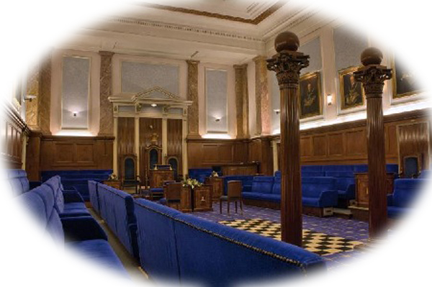
After our tour, we donned our regalia and made our way to the Chapter Temple to witness the Ceremony of the Veils and Exultation. Quite a lengthy ceremony but most interesting and very impressive. If you have not witnessed the ceremony I strongly urge you to attempt to see it sometime in the future. I feel sure you will be as impressed as we all were. Remembering all the passwords was a bit of a challenge which a few (including me) were a bit shaky on, but as the Chapter realised this was all new to us they did prompt us a bit.

After the Holy Royal Arch Chapter was closed in peace and harmony, we made our way down to No. 2 Dining room, where we enjoyed an excellent festive buffet lunch. We were told the main dish was to be Lasagne, however we were very pleasantly surprised when we went up by table and found some excellent cold roast beef, cold ham, two types of quiche, salmon and spinach en croute, two or three types of salad, baby new potatoes and hot beef Lasagne and crusty breads. Companions were allowed to go up for seconds and some even went three times (no names!). Then they brought out several types of dessert including fresh strawberries and cream. All this followed by coffee and mints, what a feast and thoroughly enjoyed by all.

After the hearty lunch, we got on bus for return to Teignmouth, some weary brethren nodding off for most of the journey. A very memorable day and one which none of us will ever forget. A cordial invitation was left with the Companions of Whitson Chapter that they make a fraternal visit to Benevolent Chapter at some future date.

